Create Eureka Discovery Server And Register Microservices

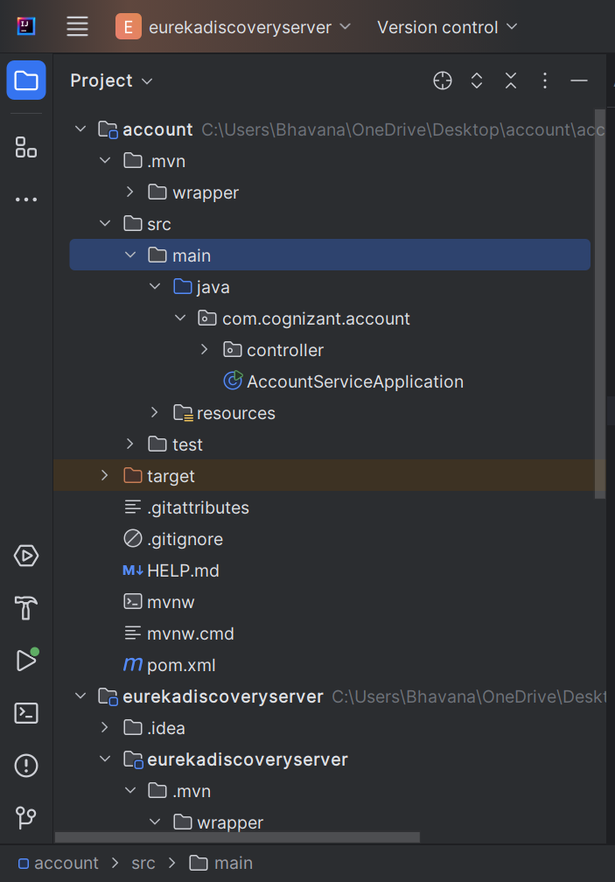

AccountServiceApplication.java
package com.cognizant.account;
import org.springframework.boot.SpringApplication;
import org.springframework.boot.autoconfigure.SpringBootApplication;
import org.springframework.cloud.client.discovery.EnableDiscoveryClient;
@SpringBootApplication
@EnableDiscoveryClient
public class AccountServiceApplication {
public static void main(String[] args) {
SpringApplication.run(AccountServiceApplication.class, args);
}
}

AccountController.java
package com.cognizant.account.controller;
import org.springframework.web.bind.annotation.GetMapping;
import org.springframework.web.bind.annotation.RestController;
@RestController
public class AccountController {
@GetMapping("/account")
public String getAccountDetails() {
return "Account details from Account Service";
}
}

application.properties
spring.application.name=account-service
server.port=8081
eureka.client.service-url.defaultZone=http://localhost:8761/eureka
EurekaDiscoveryServerApplication.java
package com.cognizant.eurekadiscoveryserver;
import org.springframework.boot.SpringApplication;
import org.springframework.boot.autoconfigure.SpringBootApplication;
import org.springframework.cloud.netflix.eureka.server.EnableEurekaServer;
@SpringBootApplication
@EnableEurekaServer
public class EurekaDiscoveryServerApplication {
public static void main(String[] args) {
SpringApplication.run(EurekaDiscoveryServerApplication.class, args);
}
}

application.properties
server.port=8761
eureka.client.register-with-eureka=false
eureka.client.fetch-registry=false
logging.level.com.netflix.eureka=OFF
logging.level.com.netflix.discovery=OFF

OUTPUT:

